5.54: a) The inward (upward, radial) acceleration will be 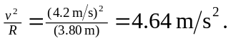 At the bottom of the circle, the inward direction is upward.
b) The forces on the ball are tension and gravity, so 